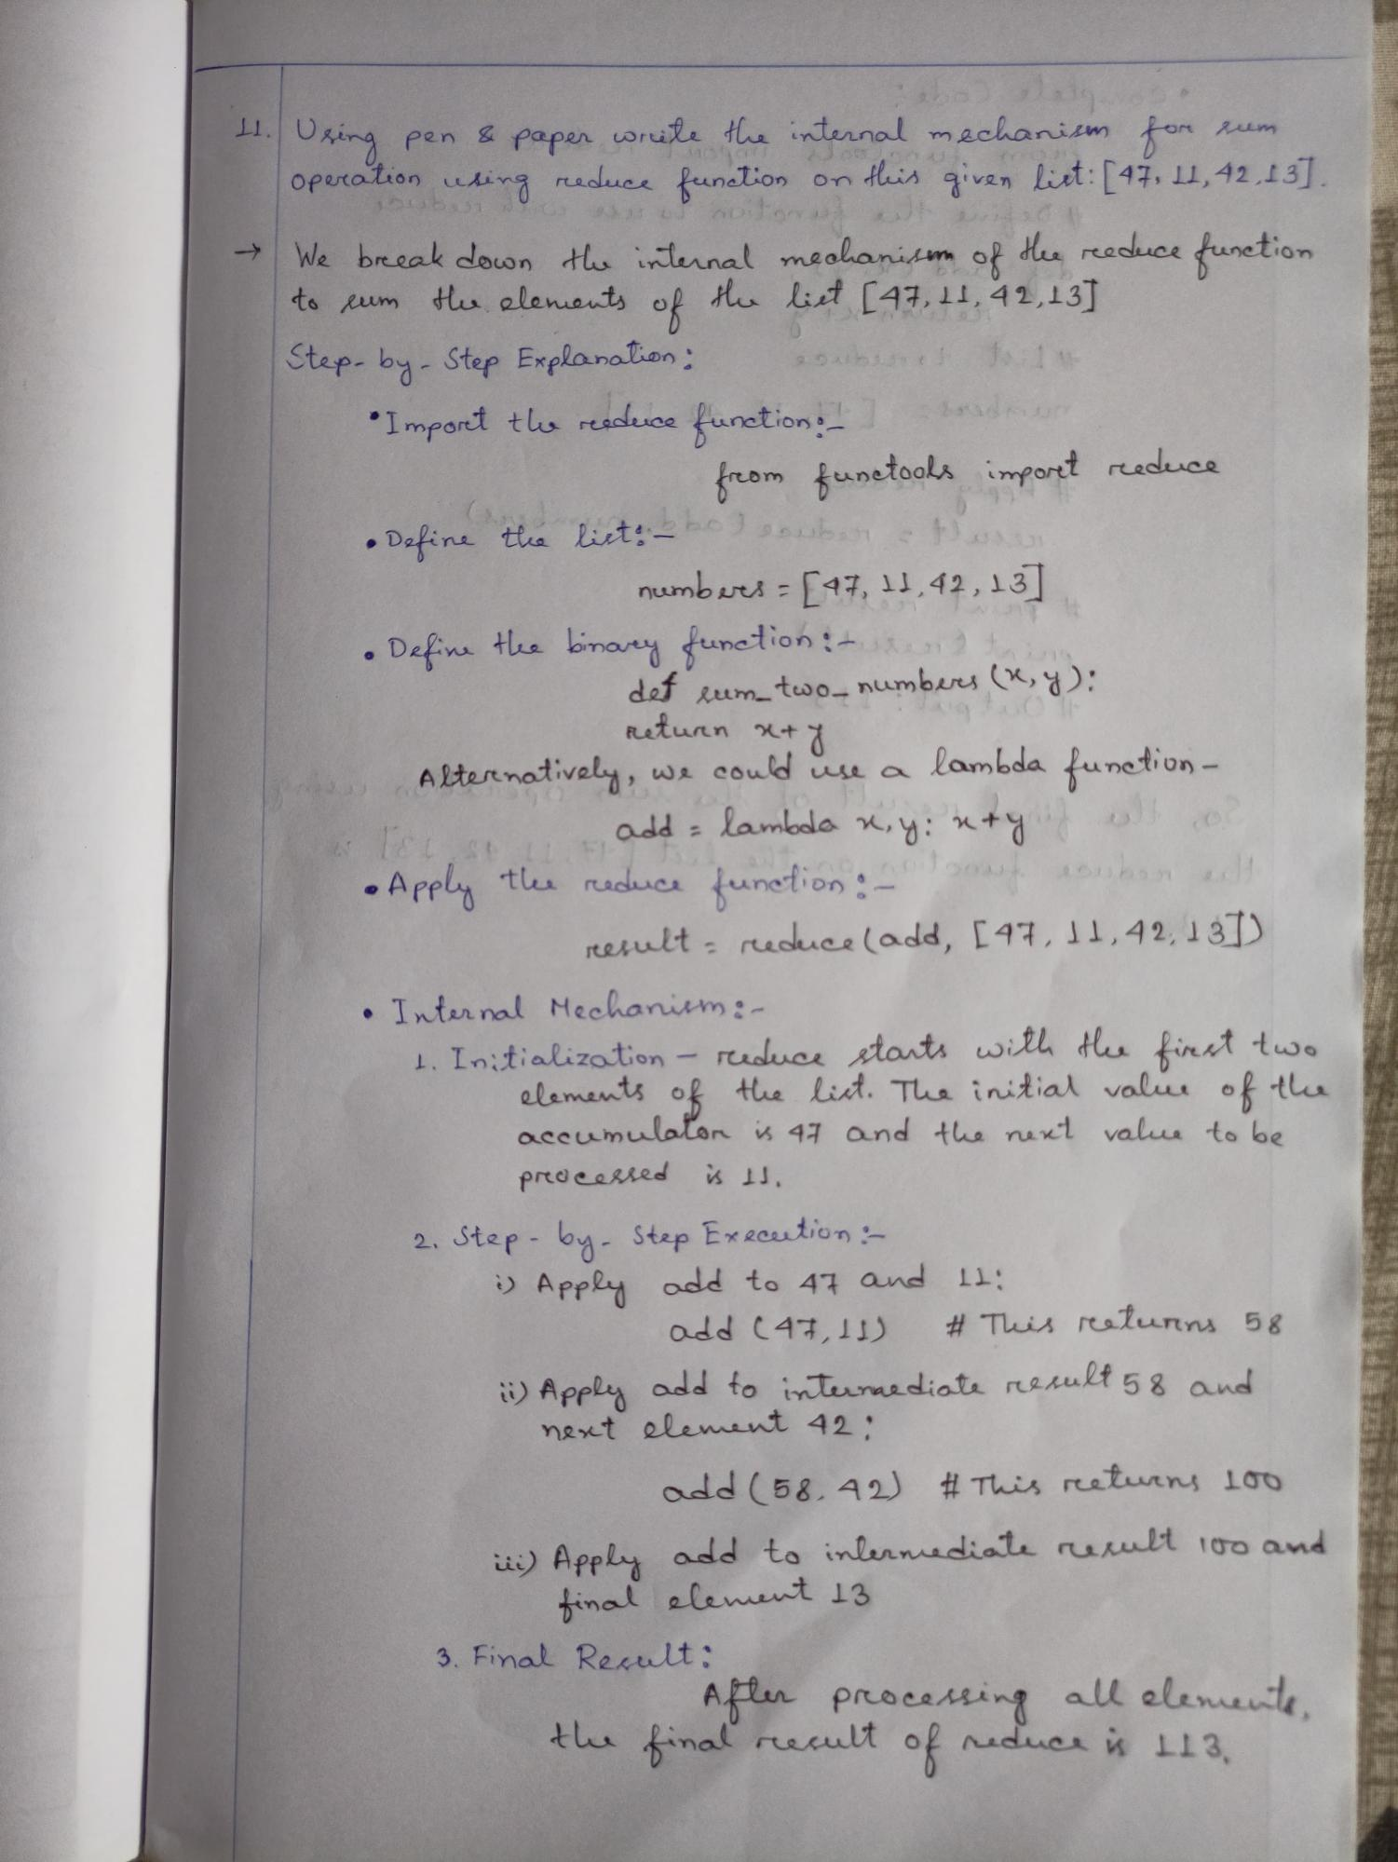

rum

11. Using pen & paper write the internal mechanism for reduce function on this given list: [47, 11,42,13].

->

Operation

using

51

We break down the internal mechanism of the reeduce function to cum the elements of the list [47, 11, 42,13]

Step-by-Step Explanation:

•Import the reeduce function: _]

from functools imporet reeduce சமயன்

Define the list: be subst

• -

numbers = [47, 11, 42, 13]

Define the binary functioning def sum_two_ numbers (x, y): Returen x+J

y

Alternatively, we could use a

T&L st 11 F

we could use a lambda function- add lambda x,y: x+y

=

• Apply the reduce function:-

x+y)

result: reduce (add, [47, 11,42,137)

• Internal Mechanism:-

1. Initialization - reduce starts with the first two elements of the list. The initial value of the accumulator is 47 and the next value to be processed is 11.

2. Step by Step Execution:-

i) Apply add to 47 and 11:

add (47, 11)

# This returns 58

ii) Apply add to intermediate result 58 and next element 42:

add (58.42) # This returns 100

iii) Apply add to intermediate result 100 and final element 13

3. Final Result:

After processing all elemente, of

the final result

reduce is 113,